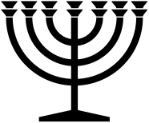 |  | June 2024
Sunday | Monday | Tuesday | Wednesday | Thursday | Friday | Saturday
 |  |  |  |  |  | 1
2 | 3 | 4 | 5 | 6 | 7 | 8
 |  |  |  |  | S | NM
9 | 10 | 11 | 12 | 13 | 14 | 15
 |  |  |  |  |  | S
16 | 17 | 18 | 19 | 20 | 21 | 22
 |  |  |  |  |  | S
23 | 24 | 25 | 26 | 27 | 28 | 29
 |  |  |  |  |  | S
30
RED = Sabbath BLUE = New Moon

